**PROJECT DEVELOPMENT PHASE-SPRINT 2**

|  |  |
| --- | --- |
| Date | 13th November 2022 |
| Team ID | PNT2022TMID30774 |
| Project Name | Personal assistance for Seniors who are self-reliant |
| Delivery | Sprint-2 |

**SPRINT 2 *-****Creating a Web UI form in Node red and upload the medicine details in*

*Cloudant DB and display the medicine to be taken by fetching it from the Cloudant database. Also Login, logout , register and session management features are included.*

# 1. **NODE RED FLOW**

The Node red flow contains nodes for login, register, entering medicine details and also session management.

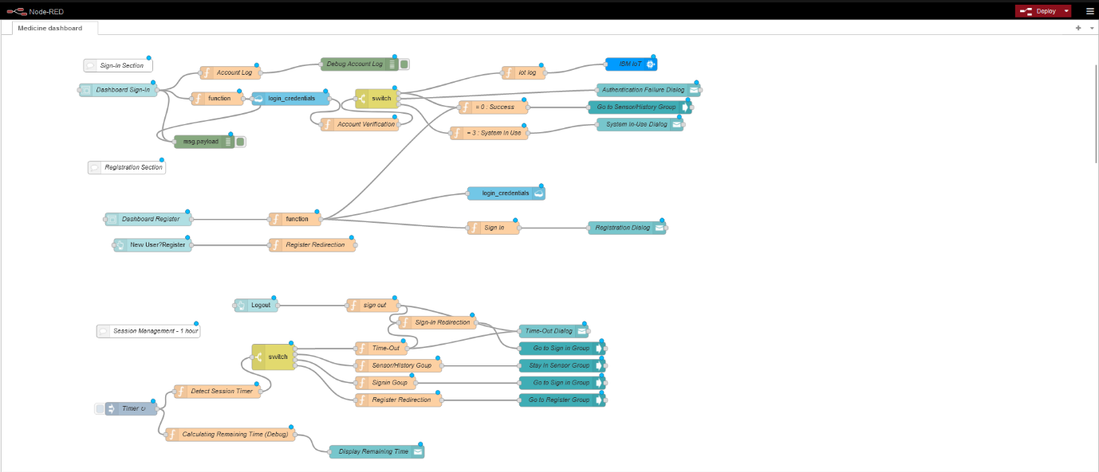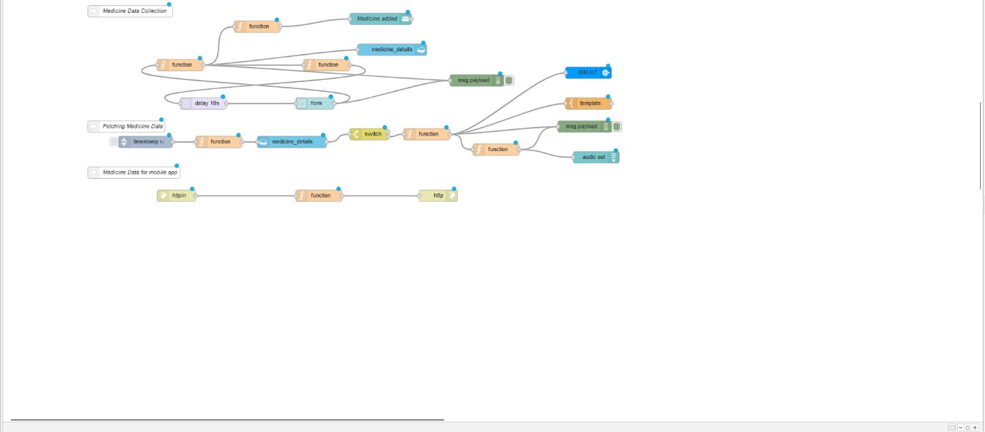

# 2. **WEB DASHBOARD**

The user can login or register using the username and password to add the medicine details. After logging in or registering the user can enter the medicine name, date and time when it has to be consumed.

* LOGIN PAGE

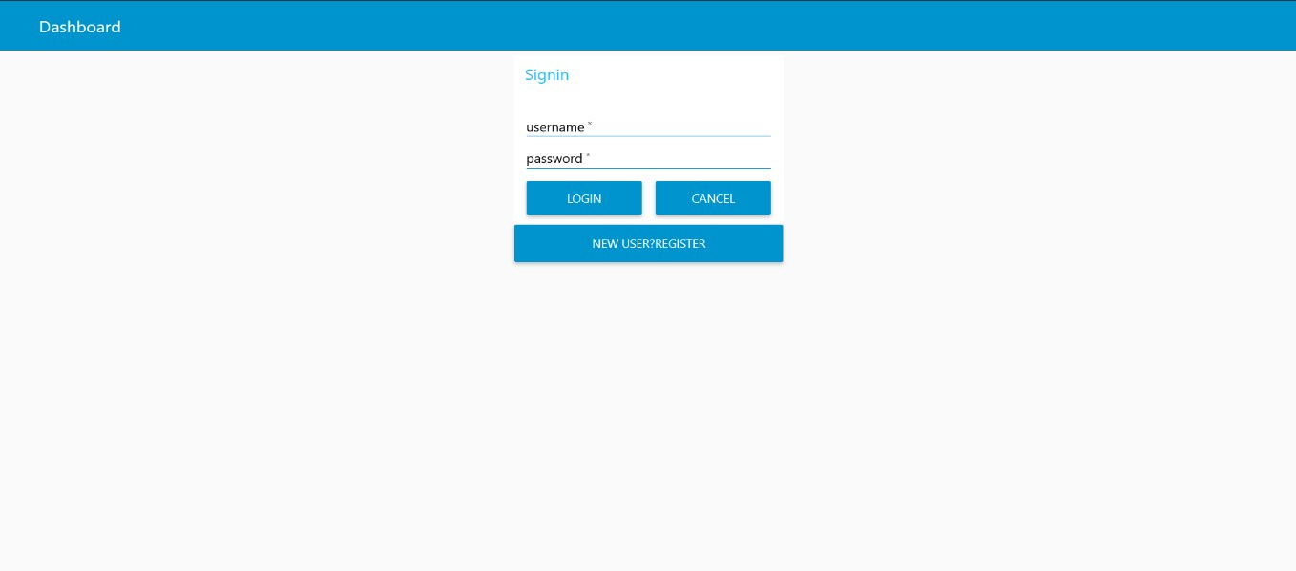

* REGISTRATION PAGE

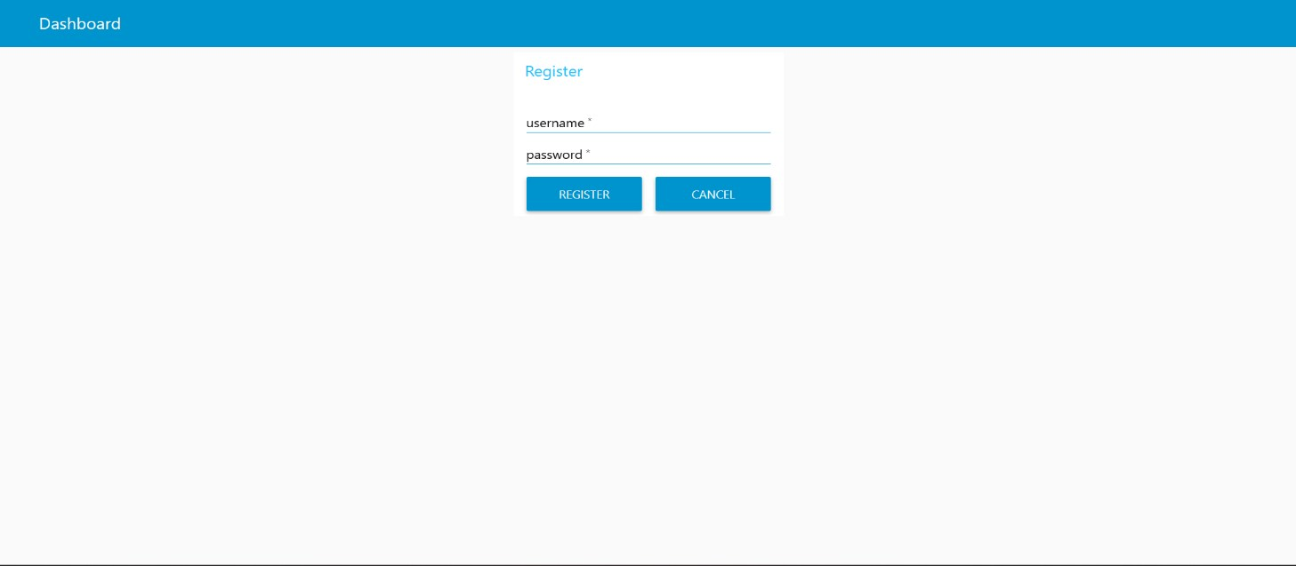

# • MEDICINE DETAILS

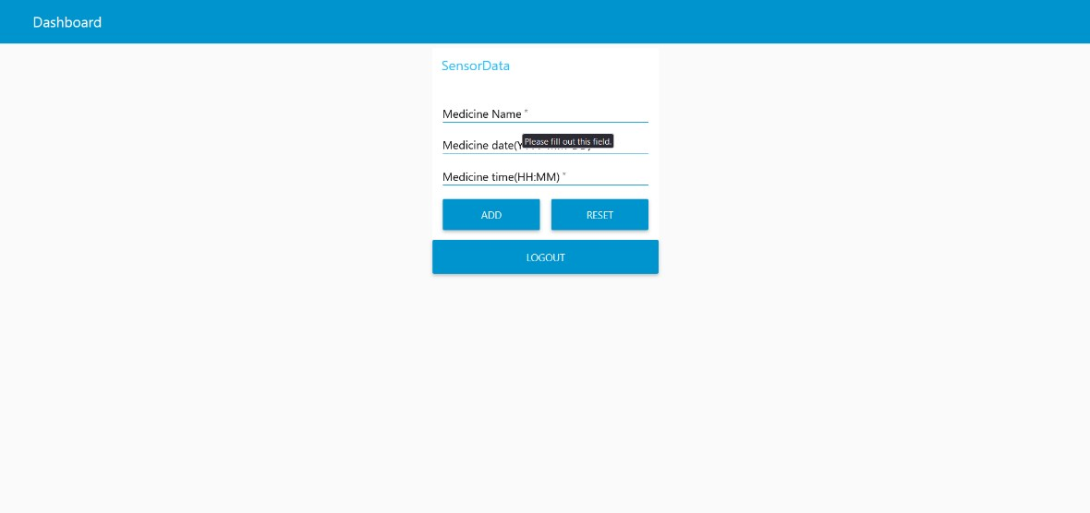

3. **CLOUDANT DATABASE**

# • LOGIN DATABASE

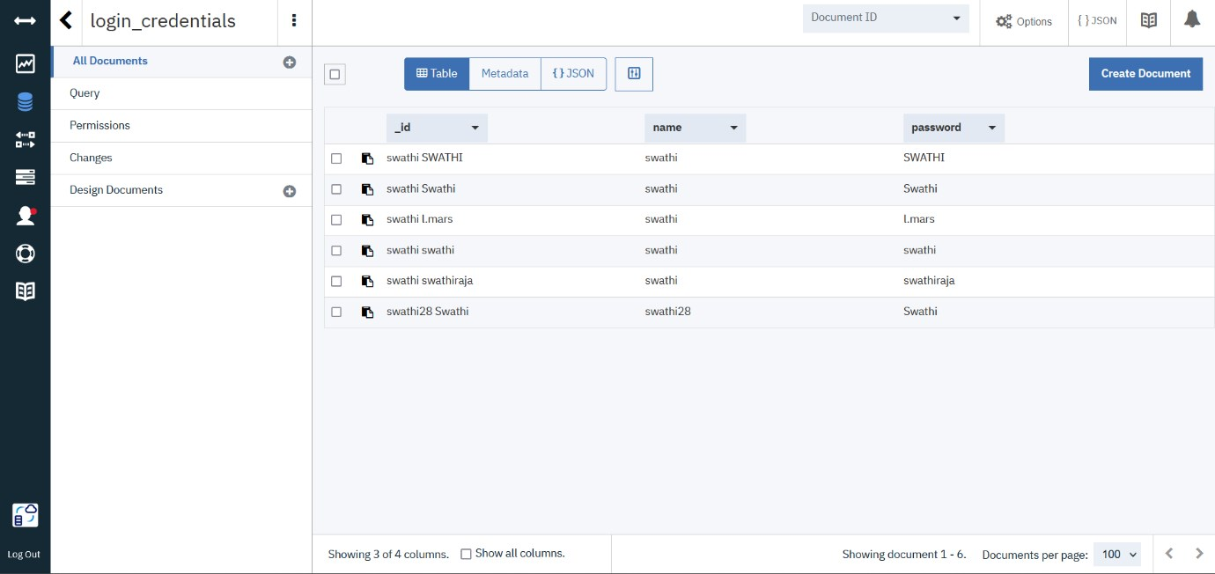

# • MEDICINE DATABASE

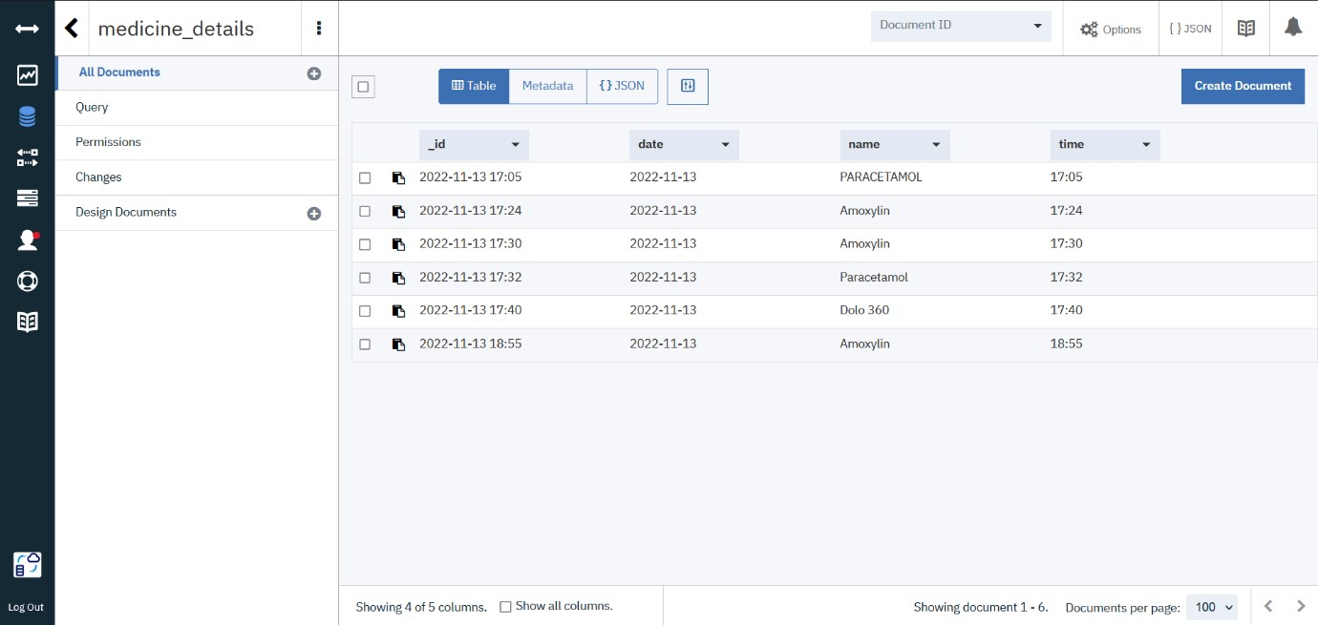

## 4. FUNCTIONALITIES

Many Features like login, logout, register and session management is done. The application logs out the user automatically when the session time crosses one hour. The dashboard is made user friendly and also gives the required information to the user.

# • LOGOUT DIALOG

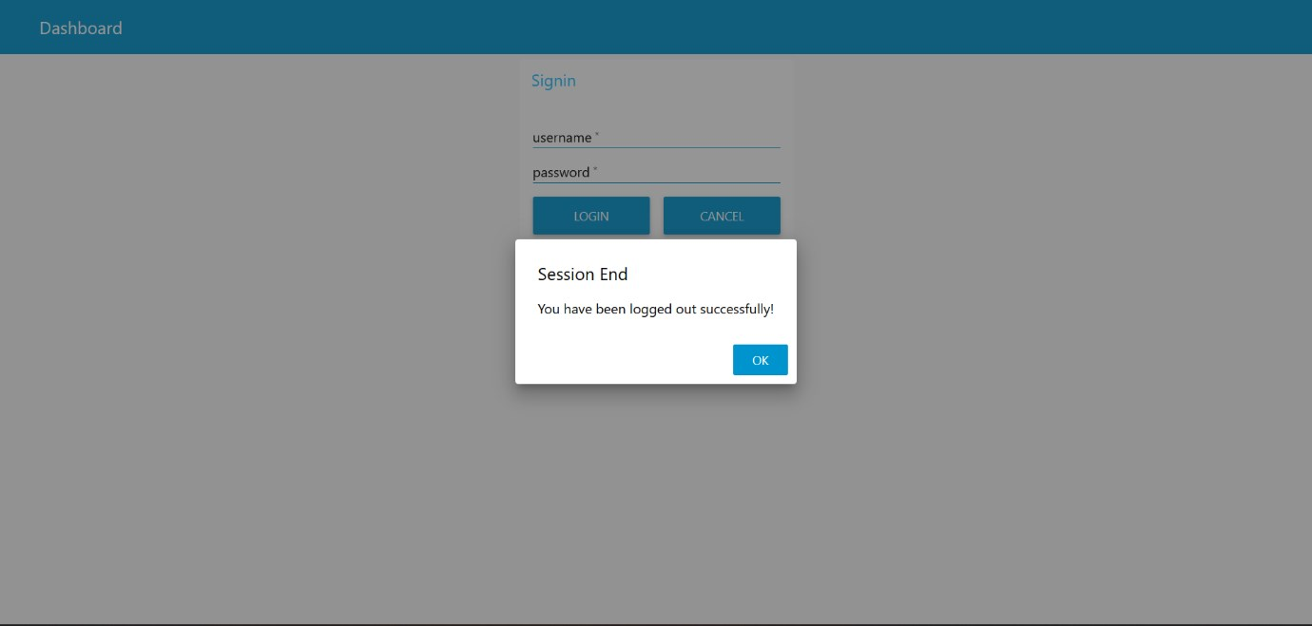

# • MEDICINE ADDED DIALOG

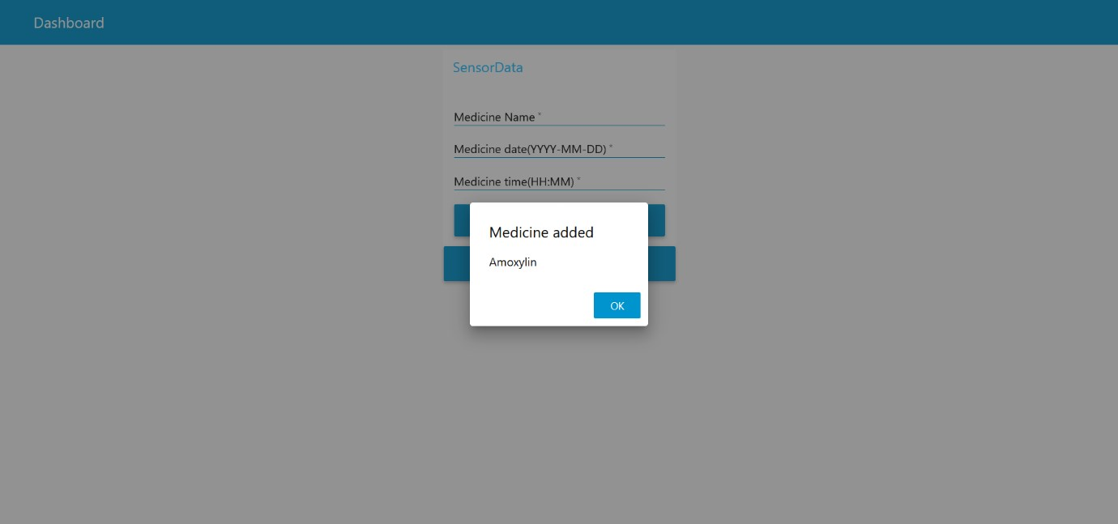

# • NOTIFIED WHEN TIME ARRIVES TO TAKE THE MEDICINE

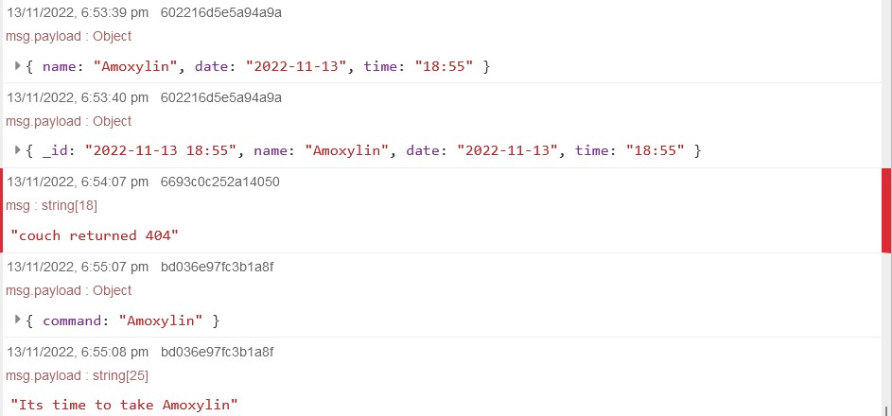

A voice message is played speaking out the command i.e. “Its time to take {{medicine_name}}” when the time arrives.

This also sends a command to the IBM IoT Watson platform which would be used further to issue command to the IoT device.IBM Iot Watson platform also get’s the data when a user logs in into the application.

